Optical Digital Book
Mobile Application Development Project-Complex Engineering Problem
By
Ms. Mariam Memon



Assignment submitted to MUET for the degree of
Bachelor of Engineering
In
Software Engineering

Assignment submitted by
22SW006
22-21SW124

October 2025
Project Title:
Ali Optical Digital Book – Cross-Platform Mobile Application

1. Real World Problem Identification
The proposed mobile application, Ali Optical Digital Book, addresses the challenge of delivering accessible and readable educational or product content to users across different devices. Many users face difficulties accessing optical or educational materials due to inconsistent UI across platforms and limited offline access.
This project solves the real-world problem of ensuring accessibility, readability, and synchronization of content for users on both mobile phones and tablets — with or without an internet connection.

2. Problem Statement
Develop a cross-platform mobile application that provides a digital book or optical content experience. The app will allow users to access, read, and manage product content seamlessly across devices, ensuring consistent UI, offline capability, and cloud synchronization.

3. Stakeholders
- Developers and Maintainers: Responsible for coding, updates, and maintenance.
- Content Owners: Authors, publishers, or businesses providing optical/educational material.
- QA Testers and Accessibility Auditors: Ensure usability, performance, and accessibility compliance.
- Administrators: Manage content updates, usage analytics, and user feedback.

4. Proposed Solution (High-Level Architecture)
Cross-Platform Approach
To maintain consistent UI and performance across platforms, the app will use:
- Flutter: For single codebase, responsive design, and strong device parity.
If the project is already forked from one of these stacks, the same will be continued to avoid rework.
Overall Architecture
- Presentation Layer: Responsive UI components adapting via breakpoints/media queries.
- State Management Layer: Decoupled from UI for easier maintenance and testing.
- Data Layer: Hybrid local storage and remote sync adapter.
- Services: Networking, authentication (optional), analytics, and error tracking.
- CI/CD: Automated builds, static analysis, and testing for Android and iOS.

5. Responsive User Interfaces
Requirements Mapping
- Constraint: Must function uniformly across all screen sizes and platforms.
- Strategy: Implement fluid layouts using flex or percentage-based design.
- Testing Layouts:
  - Phone portrait
  - Phone landscape
  - Tablet portrait
  - Tablet landscape
Visual and Interaction Recommendations
- Adjustable font size, line spacing, dark/light mode, and margin settings.
- Touch targets must follow accessibility standards (≥ 44px).
- Adaptive navigation patterns:
  - Bottom navigation on phones
6. Screenshots / Evidence
Include screenshots in the repository under the /screenshots directory:
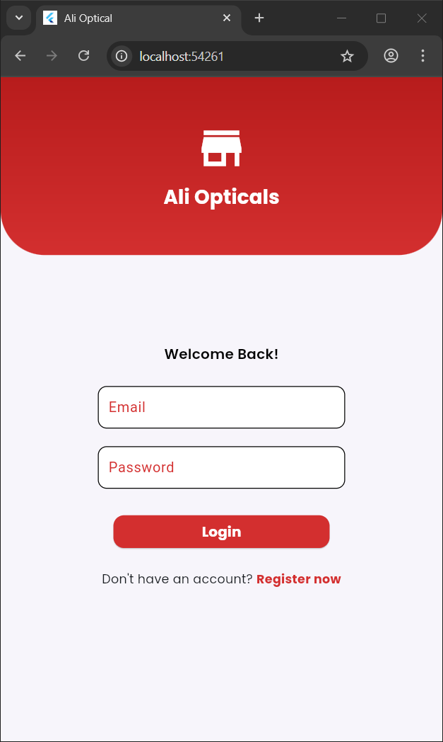
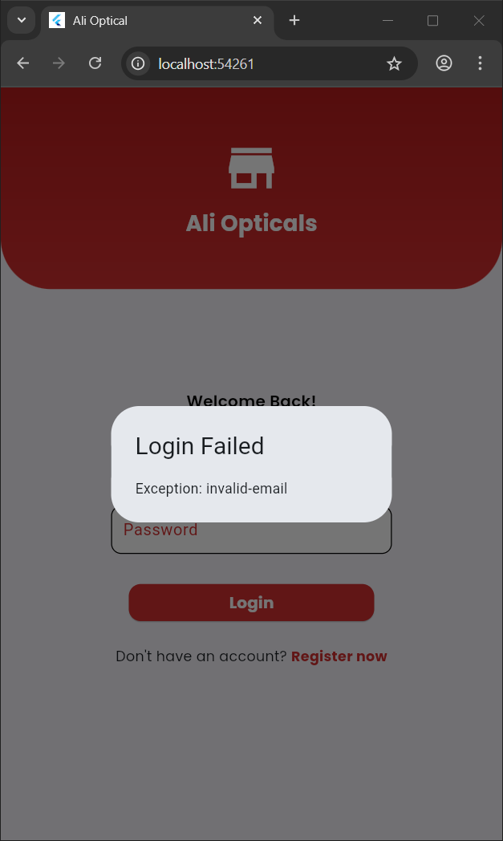
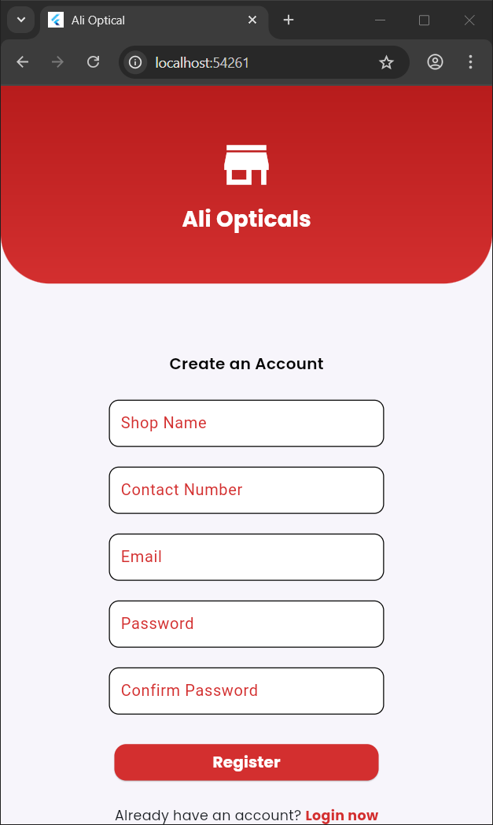
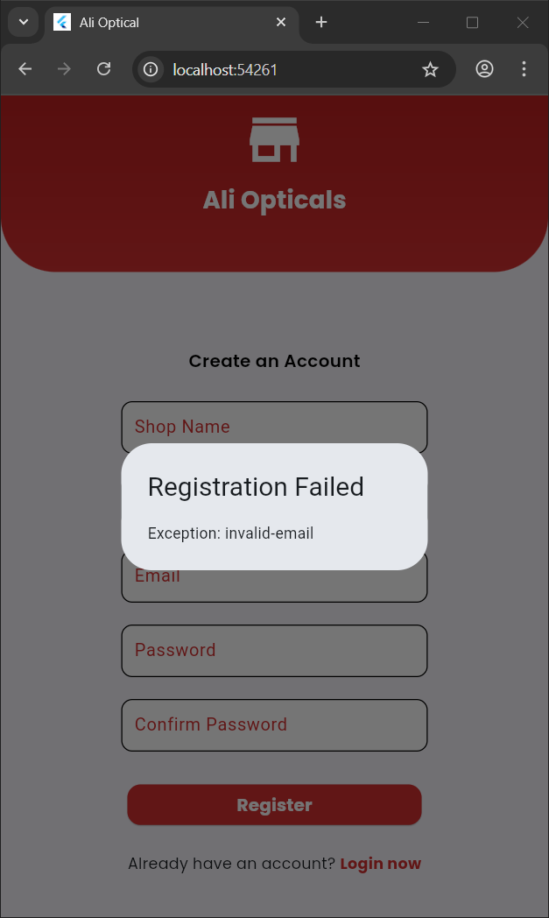
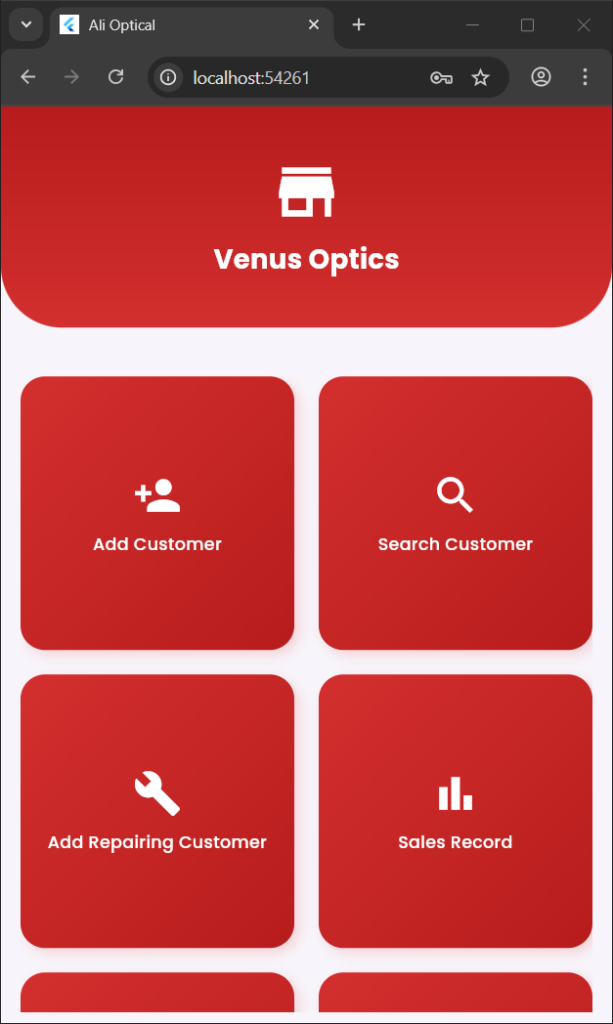
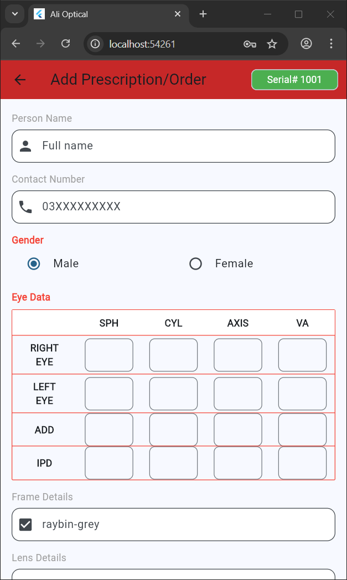
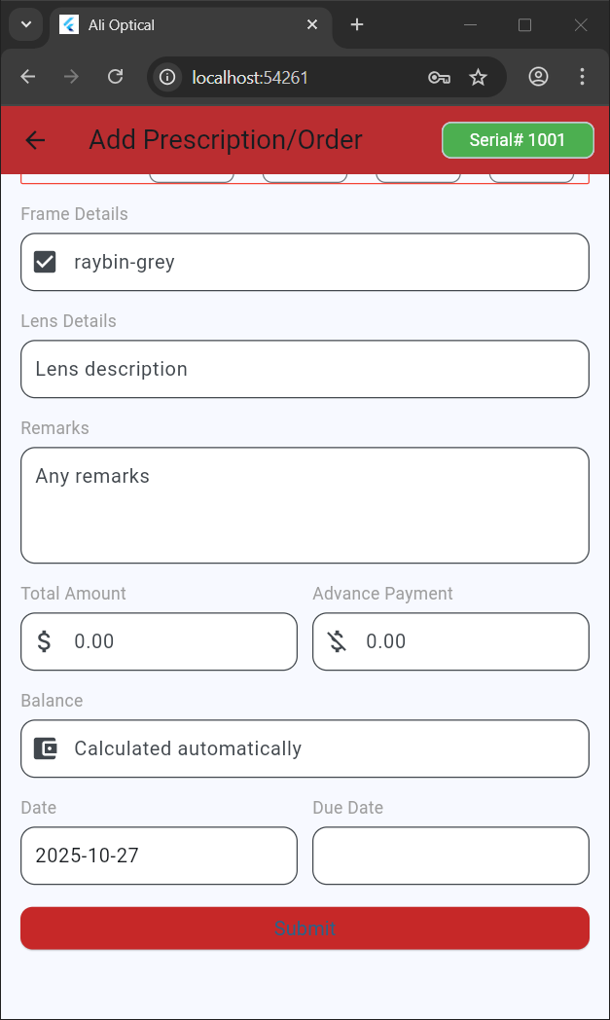
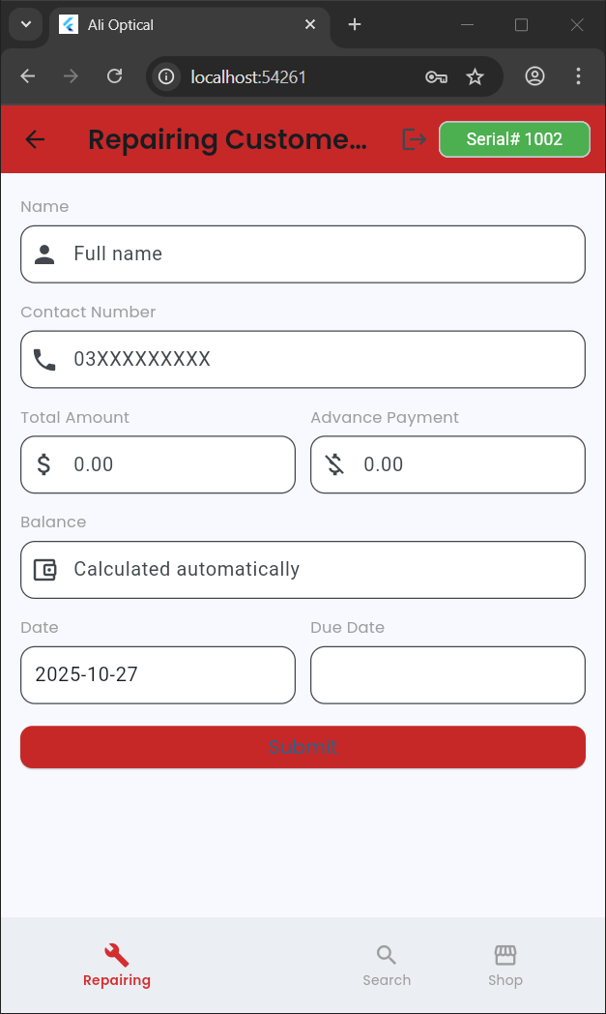

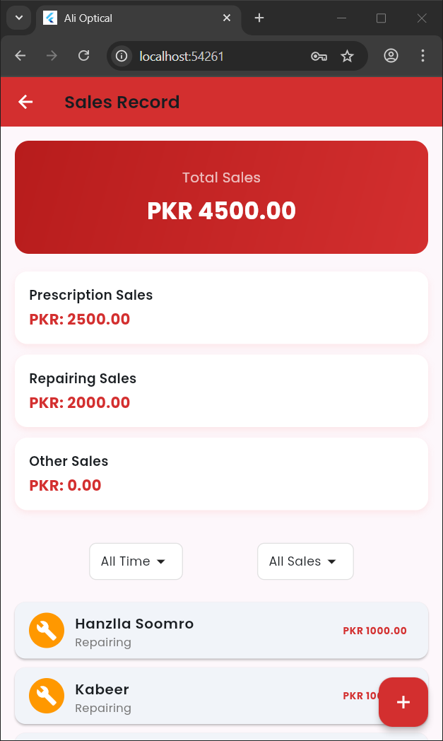
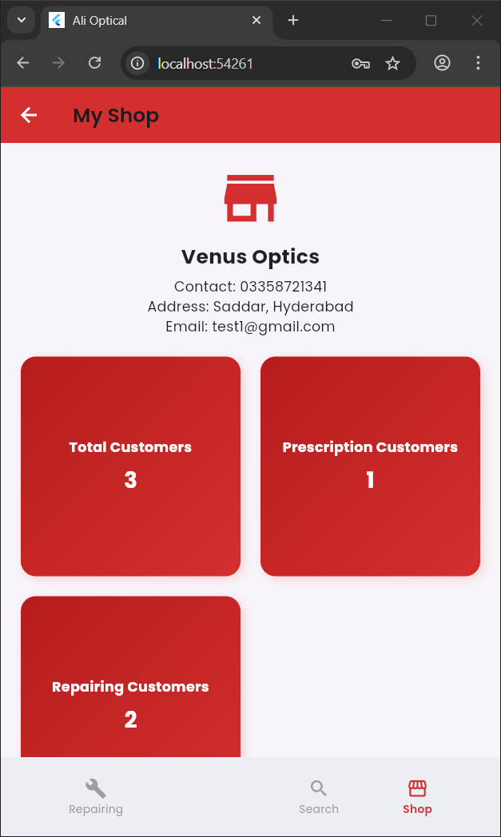
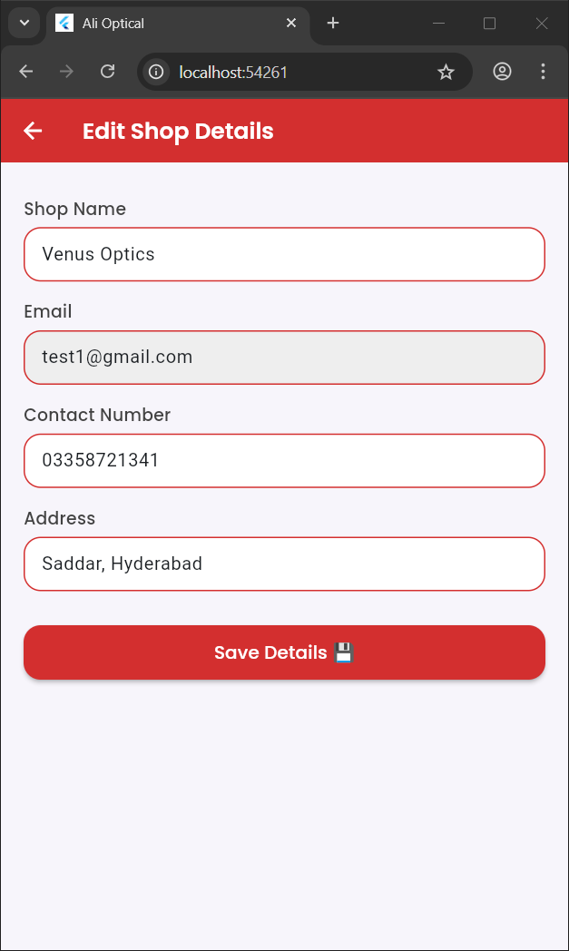
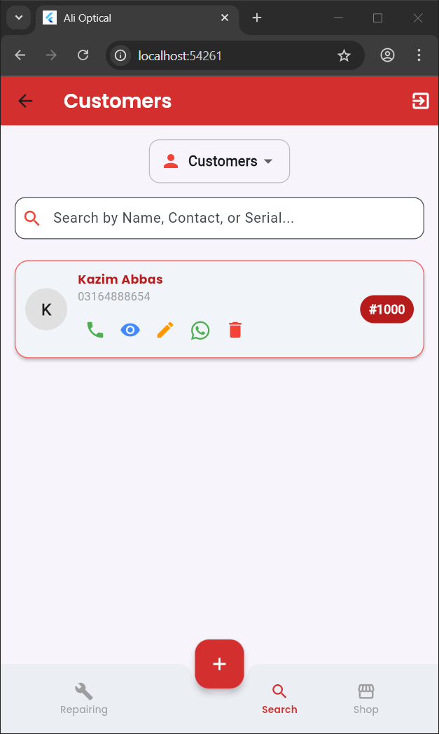
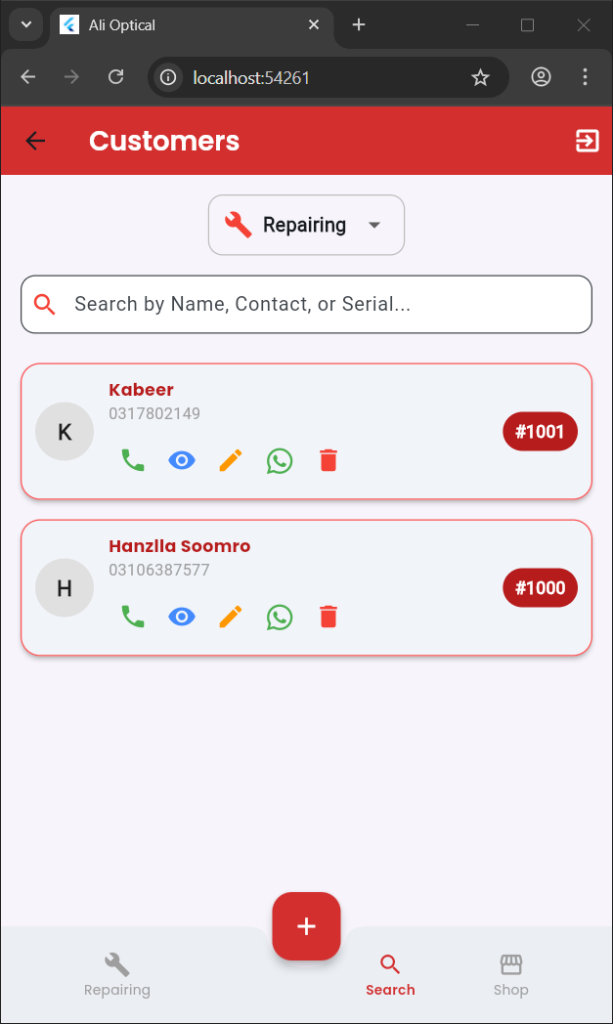
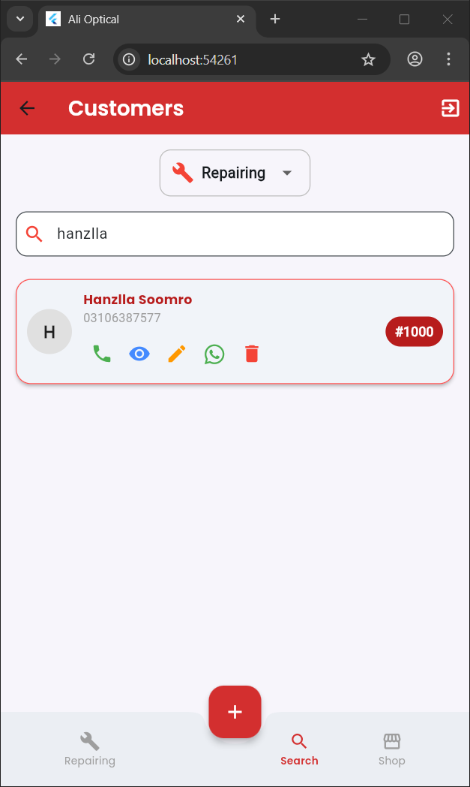
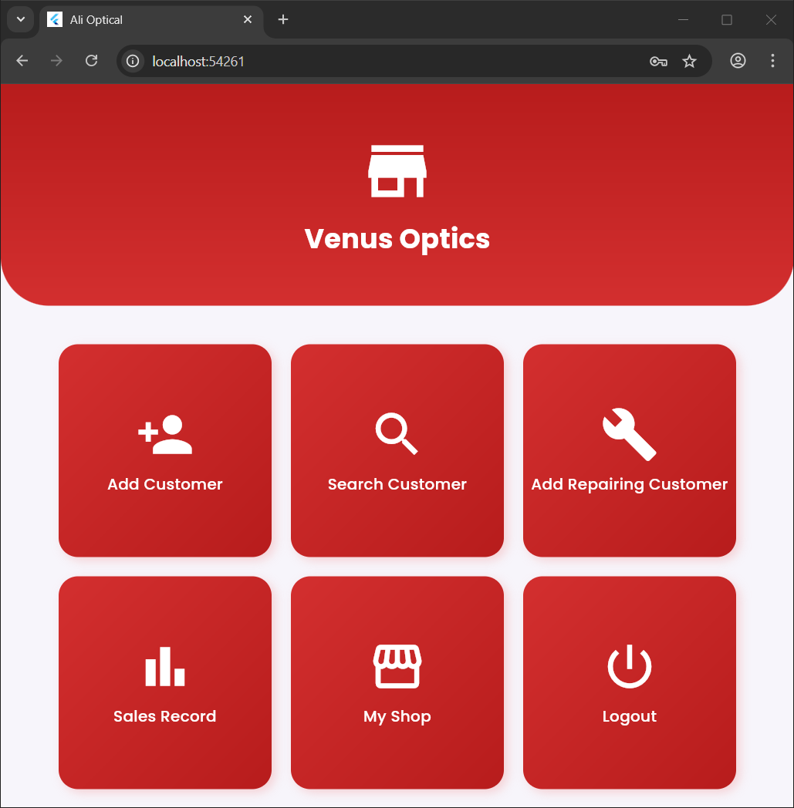

Capture examples from both Android and iOS emulators to demonstrate responsive design.

7. Data Storage (with Justification)
Considerations
Offline reading, bookmarking, progress tracking, and user preference persistence are essential.
Recommended Hybrid Approach
- Local Storage:
  - Use SQLite (via sqflite or react-native-sqlite-storage
  - Store large files (PDFs, EPUBs) in app-specific local directories.
- Cloud Storage:
  - Use Firebase Firestore + Storage for cloud sync and content updates.
Justification
- Local-first architecture: Enables fast, offline access.
- Cloud integration: Ensures synchronization, analytics, and data backup.
- Scalability: Firebase provides robust tools for future app growth.

8. State Management
For Flutter
- Small-scale: Provider + ChangeNotifier
- Complex apps: Riverpod + state_notifier for better testing and state predictability.
Recommendation
Adopting a single source of truth pattern—separating UI state from persistent data ensures clarity, scalability, and maintainability.

9. APIs / Packages / Plug-ins
• firebase_core:
- Purpose: Initializes Firebase services within the app.
- Justification: Essential for connecting the app to Firebase’s backend services, enabling features like authentication and Firestore. Provides a stable foundation for other Firebase functions.
• firebase_auth:
- Purpose: Manages user authentication for login, registration, and session management.
- Justification: Simplifies secure user authentication, handling login and signup without needing to build a custom authentication solution. Ensures data privacy and protection.
• cloud_firestore:
- Purpose: Provides real-time NoSQL database for storing and retrieving data, like event details, guest lists, tasks, and budgets.
- Justification: Firestore’s scalability and real-time capabilities make it ideal for dynamic data updates. Its structure also simplifies data storage and retrieval across multiple users and devices.
10. Issues and Bugs Encountered and Resolved

Problem 1: The term 'pub' is not recognized as the name of a cmdlet, function, script file, or operable program.
PS E:\Flutter Projects\alioptical> pub install firebase_core
pub : The term 'pub' is not recognized as the name of a cmdlet, function, script file, or operable program. Check the spelling of the name, or if a path was included, verify that
the path is correct and try again.
At line:1 char:1
+ pub install firebase_core
+ ~~~
+ CategoryInfo : ObjectNotFound: (pub:String) [], CommandNotFoundException
+ FullyQualifiedErrorId : CommandNotFoundException

PS E:\Flutter Projects\alioptical> flutter pub add firebase_core
Resolving dependencies...
Downloading packages... (1.4s)
characters 1.4.0 (1.4.1 available)
+ firebase_core 4.2.0
+ firebase_core_platform_interface 6.0.2
+ firebase_core_web 3.2.0
flutter_lints 5.0.0 (6.0.0 available)
+ flutter_web_plugins 0.0.0 from sdk flutter
leak_tracker 10.0.9 (11.0.2 available)
leak_tracker_flutter_testing 3.0.9 (3.0.10 available)
leak_tracker_testing 3.0.1 (3.0.2 available)
lints 5.1.1 (6.0.0 available)
material_color_utilities 0.11.1 (0.13.0 available)
meta 1.16.0 (1.17.0 available)
+ plugin_platform_interface 2.1.8
test_api 0.7.4 (0.7.7 available)
vector_math 2.1.4 (2.2.0 available)
vm_service 15.0.0 (15.0.2 available)
+ web 1.1.1
Changed 6 dependencies!
11 packages have newer versions incompatible with dependency constraints.
Try `flutter pub outdated` for more information.
PS E:\Flutter Projects\alioptical> flutter pub add firebase_auth
Resolving dependencies...
Downloading packages... (1.4s)
+ _flutterfire_internals 1.3.63
characters 1.4.0 (1.4.1 available)
+ firebase_auth 6.1.1
+ firebase_auth_platform_interface 8.1.3
+ firebase_auth_web 6.0.4
flutter_lints 5.0.0 (6.0.0 available)
+ http 1.5.0
+ http_parser 4.1.2
leak_tracker 10.0.9 (11.0.2 available)
leak_tracker_flutter_testing 3.0.9 (3.0.10 available)
leak_tracker_testing 3.0.1 (3.0.2 available)
lints 5.1.1 (6.0.0 available)
material_color_utilities 0.11.1 (0.13.0 available)
meta 1.16.0 (1.17.0 available)
test_api 0.7.4 (0.7.7 available)
+ typed_data 1.4.0
vector_math 2.1.4 (2.2.0 available)
vm_service 15.0.0 (15.0.2 available)
Changed 7 dependencies!
11 packages have newer versions incompatible with dependency constraints.
Try `flutter pub outdated` for more information.
PS E:\Flutter Projects\alioptical> git push origin master
Enumerating objects: 7, done.
Counting objects: 100% (7/7), done.
Delta compression using up to 12 threads
Compressing objects: 100% (4/4), done.
Writing objects: 100% (4/4), 428 bytes | 428.00 KiB/s, done.
Total 4 (delta 2), reused 0 (delta 0), pack-reused 0 (from 0)
remote: Resolving deltas: 100% (2/2), completed with 2 local objects.
To https://github.com/Hanzllasoomro/alioptical.git
c6f0dbf..44fe141 master -> master
PS E:\Flutter Projects\alioptical> git status
On branch master
Your branch is up to date with 'origin/master'.

nothing to commit, working tree clean
PS E:\Flutter Projects\alioptical> git pull origin master
remote: Enumerating objects: 8, done.
remote: Counting objects: 100% (8/8), done.
remote: Compressing objects: 100% (3/3), done.
remote: Total 5 (delta 2), reused 4 (delta 2), pack-reused 0 (from 0)
Unpacking objects: 100% (5/5), 1.25 KiB | 127.00 KiB/s, done.
From https://github.com/Hanzllasoomro/alioptical
* branch master -> FETCH_HEAD
44fe141..d95736e master -> origin/master
Updating 44fe141..d95736e
Fast-forward
lib/main.dart | 2 +-
1 file changed, 1 insertion(+), 1 deletion(-)

Problem 2:
PS E:\Flutter Projects\alioptical\lib\pages> touch "" > dashboard.dart
touch : The term 'touch' is not recognized as the name of a cmdlet, function,
script file, or operable program. Check the spelling of the name, or if a path
was included, verify that the path is correct and try again.
At line:1 char:1
+ touch "" > dashboard.dart
+ ~~~~~
+ CategoryInfo : ObjectNotFound: (touch:String) [], CommandNotFoundE
xception
+ FullyQualifiedErrorId : CommandNotFoundException

Problem 3:
PS E:\Flutter Projects\alioptical> git push origin main
error: src refspec main does not match any
error: failed to push some refs to 'https://github.com/Hanzllasoomro/alioptical.git'

Problem 4:
======== Exception caught by rendering library =======================
The following assertion was thrown during layout:
A RenderFlex overflowed by 36 pixels on the bottom.
Problem 5 : Responsive Layout Problems:
UI elements such as cards, buttons, and dropdowns misaligned on tablets and wide screens.
Solution: Used MediaQuery to detect screen width (isWide) and applied adaptive padding, font size, and widget arrangement.

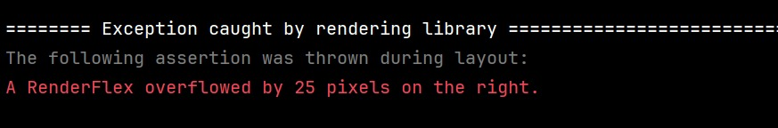
Problem 7: State Management Complexity:
Maintaining real-time updates between CustomerSearchScreen and detail screens caused inconsistencies.
Solution: Adopted StreamBuilder with Firestore snapshots for automatic UI refresh and state synchronization.
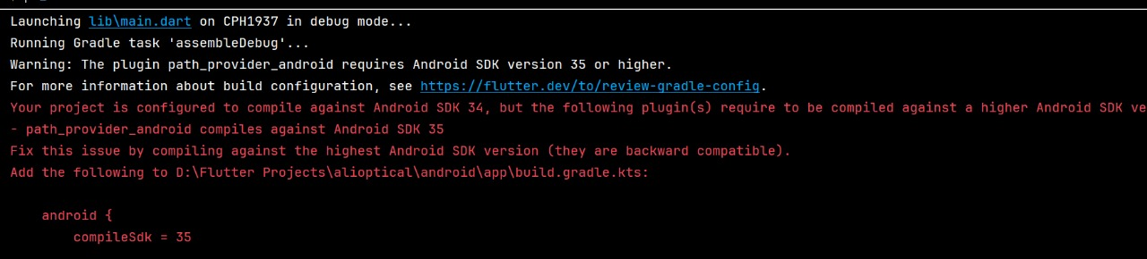
Problem 8: Navigation Challenges:
Navigating between CustomerSearchScreen, CustomerReceiptScreen, and other pages occasionally caused context loss.
Solution: Used Navigator.push with proper MaterialPageRoute and ensured safe context handling after async calls.
Problem 9: Firestore Collection Mismatch:
Some screens used "customers" while others used "customer" or "repairing_customers", causing missing data issues.
Solution: Unified collection names and applied conditional collection logic based on dropdown selection.
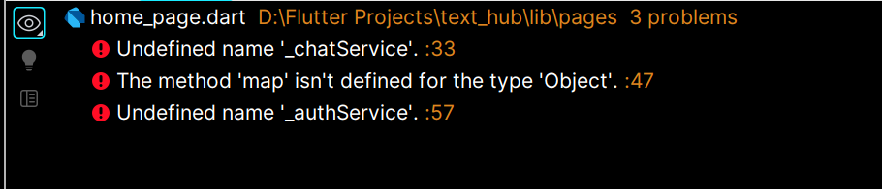
Problem 10: Data Fetching Errors:
Firestore queries failed when fields like userId or shopId were missing.
Solution: Added null-checking and default values to prevent runtime errors and show helpful SnackBar messages.
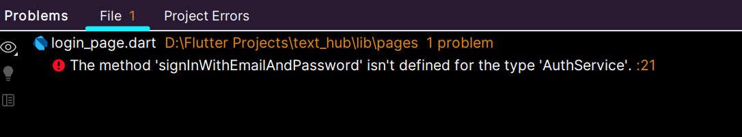
Problem 11: Null Data Crashes:
Attempting to access null Firestore fields (data['serialNo'], data['name'], etc.) caused app crashes.
Solution: Added null-aware operators (??) and string safety when rendering UI text.
Problem 12:Asynchronous Data Fetch Timing:
CustomerReceiptScreen tried rendering before Firestore data was fetched, leading to blank screens.
Solution: Displayed a CircularProgressIndicator until userData and customerData were loaded.
Problem 13: Dynamic Collection Filtering Errors:
Switching between "Customers" and "Repairing" in the dropdown didn’t refresh the list properly.
Solution: Wrapped DropdownButton in setState() to trigger UI rebuild with updated Firestore stream.
Problem 14: Search Function Inaccuracy:
Search bar filtering sometimes didn’t reflect new Firestore updates.
Solution: Used .toLowerCase() normalization and called setState() on TextField.onChanged for live filtering.
Problem 15: Incorrect Document Reference in Customer Cards:
_CustomerCard tried to access doc.id without having it in scope, breaking navigation to receipts.
Solution: Passed both doc.id and doc.data() to _CustomerCard as constructor arguments.
Problem 16: Missing User and Shop Linking:
Customer records lacked proper linkage to the shop or user, making receipts incomplete.
Solution: Stored both userId and shopId in each customer document during creation and fetched them dynamically before navigation.
Problem 17: WhatsApp and Call URL Launch Errors:
url_launcher failed to open WhatsApp for some phone numbers.
Solution: Used .replaceAll('+', '') and validated the contact format before launching URLs.
Problem 18: Firestore Ordering Conflicts:
Using .orderBy("createdAt") caused runtime errors when the field was missing in some documents.
Solution: Ensured all new records include createdAt and handled missing timestamps gracefully.
Problem 19: Printing Layout Issues:
Generated receipts from Printing.convertHtml had misaligned data and missing formatting.
Solution: Used inline CSS and structured HTML tables for consistent layout in printed receipts.
Problem 20: App Logout Inconsistency:
Signing out didn’t always clear session data, causing old user data to appear.
Solution: Used a centralized AuthService.signOut() method and ensured full Firebase auth state reset on logout.
Problem 21:
PS E:\Flutter Projects\alioptical> git status
On branch master
Your branch is up to date with 'origin/master'.
Changes to be committed:
(use "git restore --staged <file>..." to unstage)
new file: lib/pages/addRepairingCustomerScreen.dart
new file: lib/pages/customerReceiptScreen.dart
Changes not staged for commit:
(use "git add <file>..." to update what will be committed)
(use "git restore <file>..." to discard changes in working directory)
modified: lib/components/bottomNavBar.dart
modified: lib/pages/addRepairingCustomerScreen.dart
modified: lib/pages/customerReceiptScreen.dart
modified: lib/pages/customerSearchScreen.dart
modified: lib/pages/dashboard.dart
modified: pubspec.lock
modified: pubspec.yaml

Problem 22:
RenderFlex Overflow Error
Issue:
A RenderFlex overflowed by X pixels on the bottom occurred when column contents exceeded the available height.
Resolution:
Wrapped the Column with SingleChildScrollView or used Expanded inside Flex layouts to prevent overflow on smaller screens.
Problem 23. Navigation Error – Missing Required Parameter
Issue:
Error: Required named parameter 'shopName' must be provided appeared when navigating from EditShopScreen to MyShopScreen.
Resolution:
Added required parameters (shopName, etc.) and passed updated data back properly via Navigator.pushReplacement() with constructor arguments.
Problem 24. Improper UI Padding in Header Container
Issue:
The top container in MyShopScreen had excessive bottom padding and caused misalignment with the scrollable content.
Resolution:
Used a Stack layout so the rest of the content scrolls behind the header container, reducing padding and improving visual hierarchy.
Problem 25. Responsiveness Across Devices (Web, iOS, Android)
Issue:
Layouts broke on wider screens (web/tablet).
Resolution:
Implemented MediaQuery.of(context).size.width checks (isWide) and adaptive paddings, font sizes, and grid column counts.
Problem 26. Cherry-Pick Merge Conflicts
Issue:
During git cherry-pick, merge conflicts occurred in dashboard.dart because master and another branch diverged.
Resolution:
Resolved conflicts manually, staged changes, and continued cherry-pick using git add . → git cherry-pick --continue.

Problem 27. Diverged Branch Issue
Issue:
Git showed:
Your branch and 'origin/master' have diverged...
Resolution:
Used git fetch origin followed by git reset --hard origin/master to align local code with remote master safely.
Problem 28. Data Not Returning from Firestore
Issue:
“User or Shop ID missing in record” Snackbar was shown because IDs were not fetched properly.
Resolution:
Fetched document data based on the selectedType variable, dynamically using correct Firestore collections (customers or repairing_customers).
Problem 29. Incorrect Firestore Collection Access
Issue:
The app tried fetching data from a wrong collection regardless of customer type.
Resolution:
Used conditional logic:
final collection = selectedType == 'Repairing'
? 'repairing_customers'
: 'customers';
Problem 30. Missing Data Validation Before Navigation
Issue:
Navigation to CustomerReceiptScreen occurred even when Firestore record was incomplete.
Resolution:
Added null and key existence checks before using userId and shopId.
Problem 31. SnackBar Not Displaying in Some Cases
Issue:
ScaffoldMessenger.of(context) not showing Snackbar when used inside asynchronous operations.
Resolution:
Used ScaffoldMessenger.of(context).showSnackBar() directly inside setState or after async completion.
Problem 32. Improper State Handling in Search
Issue:
Search filtering didn’t update properly when query changed.
Resolution:
Wrapped list filtering in setState() and converted all customer data to lowercase before comparison.
Problem 33. FloatingActionButton Overlapping Bottom Navigation
Issue:
The FloatingActionButton overlapped bottom icons.
Resolution:
Used BottomAppBar with CircularNotchedRectangle() and FloatingActionButtonLocation.centerDocked.
Problem 34. Duplicate UI Logic in Bottom Navigation Bar
Issue:
Bottom navigation was repeated across multiple screens.
Resolution:
Extracted it into a reusable widget BottomNavBar(currentIndex: x) and handled navigation using onTap callbacks.
Problem 35. Improper Text Scaling on Large Screens
Issue:
Fonts looked inconsistent on tablets and web.
Resolution:
Used adaptive font sizes like:
fontSize: isWide ? 24 : 18,
based on screen width via MediaQuery.
Problem 36. UI Freezes Due to Scrollable GridView
Issue:
Nested GridView inside SingleChildScrollView caused layout errors.
Resolution:
Added:
shrinkWrap: true,
physics: NeverScrollableScrollPhysics(),
to allow proper rendering inside scroll views.

11. Maintainability and Coding Standards
Code Hygiene
- Use linting tools (dart analyze / eslint).
- Maintain feature-based modular architecture.
- Add documentation: CONTRIBUTING.md, CODE_OF_CONDUCT.md, and DESIGN.md.
- Include unit and integration tests for reading logic and data sync.
Repository Improvements
- Add detailed README.md (build/run instructions, screenshots).
12. Security and Privacy
If user data or cloud sync is included:
- Enforce Firestore security rules.
- Store secrets securely (not in source code).
- Ensure analytics are user-consented and anonymized.

13. Accessibility
To ensure inclusivity and usability:
- Scalable font sizes and readable color contrast.
- Screen reader labels all controls.
- Minimum tappable area of 44x44 px.
- Announce state changes (e.g., theme, page turns) to assistive tech.

14. Project Deliverables Mapping
Working Application
- GitHub Repository: https://github.com/Hanzllasoomro/alioptical.git
- Branch: master
Deliverables
- Working Android/iOS app build
- Project REPORT.md or PDF document (this report)
- Responsive UI screenshots
- Data storage & API integration
- Log of encountered and resolved issues
- Explanation of how all constraints are met

15. Conclusion
The Ali Optical Digital Book mobile application demonstrates an accessible, reliable, and scalable approach to digital content distribution. With its hybrid offline-online architecture, responsive design, and maintainable code structure, the app provides a modern reading experience suitable for both educational and product-based content delivery.

